**Mini-Project 3**

Group Members: Sathya Pooja Ramireddy (sxr176830)

Sashidhar Donthiri(sxd173730)

Contributions:

Both of us have individually tried solving the problems, and came up solutions, further discussed and put it together.

1)

(a) **Calculate Mean squared error of an estimator using Monte Carlo(MC) Simulation**:

Given theta hat be our estimator of parameter θ(theta) can be computed using MC simulation by repeating the process of simulating a sample of data and then computing theta hat from the obtained sample quite a large number of times and then computing the average of squared deviation values between theta hat and θ(theta) gives the value for mean squared error of an estimator using Monte Carlo Simulation.

(b) Given combination of (n, θ), theta hat1 and theta hat2 can be computed using Monte Carlo Simulations with N=1000 replications from independent and identical data (same data).

Assume n=1, min=0, max=5, theta=5

**R-code:**

#given (n,θ), compute mean squared errors(MSE) using Monte Carlo Simulation

#since we have to compute two estimated by simulating one sample

x_val=runif(1,0,5) #n,min,max

Max_Likelihood_est=max(x_val)

moment_Val=2*mean(x_val)

c(Max_Likelihood_est,moment_Val)

#since the replication val is 1000,n=1000

estimated_value=replicate(1000,c(Max_Likelihood_est,moment_Val))

rowMeans((estimated_value-5)^2) #computing MSE by finding the deviation of theta hat from theta

17.96177 12.08442 #MSE for theta hat 1 and theta hat 2

(c) For different combinations of n and theta:

R-code followed by their results:

#nvalues= 1

#thetavalues=1,5,50,100

x_val=runif(1,0,1) #n,min,max

Max_Likelihood_est=max(x_val)

moment_Val=2*mean(x_val)

c(Max_Likelihood_est,moment_Val)

#partial result

#since the replication val is 1000,n=1000

estimated_value=replicate(1000,c(Max_Likelihood_est,moment_Val))

rowMeans((estimated_value-1)^2) #computing MSE by finding the deviatiosn of theta hat from theta

0.35702 0380365 #result

x_val=runif(1,0,50) #n,min,max

Max_Likelihood_est=max(x_val)

moment_Val=2*mean(x_val)

c(Max_Likelihood_est,moment_Val)

#partial result

#since the replication val is 1000,n=1000

estimated_value=replicate(1000,c(Max_Likelihood_est,moment_Val))

rowMeans((estimated_value-50)^2) #computing MSE by finding the deviatiosn of theta hat from theta

1685.252 1030.644 #result

x_val=runif(1,0,5) #n,min,max

Max_Likelihood_est=max(x_val)

moment_Val=2*mean(x_val)

c(Max_Likelihood_est,moment_Val)

#partial result

#since the replication val is 1000,n=1000

estimated_value=replicate(1000,c(Max_Likelihood_est,moment_Val))

rowMeans((estimated_value-5)^2) #computing MSE by finding the deviatiosn of theta hat from theta

0.0584219 203995630#result

x_val=runif(1,0,100) #n,min,max

Max_Likelihood_est=max(x_val)

moment_Val=2*mean(x_val)

c(Max_Likelihood_est,moment_Val)

#partial result

#since the replication val is 1000,n=1000

estimated_value=replicate(1000,c(Max_Likelihood_est,moment_Val))

rowMeans((estimated_value-100)^2) #computing MSE by finding the deviatiosn of theta hat from theta

2894.130 85.64365 #result

#nvalues= 2

#thetavalues=1,5,50,100

x_val=runif(2,0,1) #n,min,max

Max_Likelihood_est=max(x_val)

moment_Val=2*mean(x_val)

c(Max_Likelihood_est,moment_Val)

#partial result

#since the replication val is 1000,n=1000

estimated_value=replicate(1000,c(Max_Likelihood_est,moment_Val))

rowMeans((estimated_value-1)^2) #computing MSE by finding the deviatiosn of theta hat from theta

.00119610 .08536198#result

x_val=runif(2,0,50) #n,min,max

Max_Likelihood_est=max(x_val)

moment_Val=2*mean(x_val)

c(Max_Likelihood_est,moment_Val)

#partial result

#since the replication val is 1000,n=1000

estimated_value=replicate(1000,c(Max_Likelihood_est,moment_Val))

rowMeans((estimated_value-50)^2) #computing MSE by finding the deviatiosn of theta hat from theta

213.9171 309.8031#result

x_val=runif(2,0,5) #n,min,max

Max_Likelihood_est=max(x_val)

moment_Val=2*mean(x_val)

c(Max_Likelihood_est,moment_Val)

#partial result

#since the replication val is 1000,n=1000

estimated_value=replicate(1000,c(Max_Likelihood_est,moment_Val))

rowMeans((estimated_value-5)^2) #computing MSE by finding the deviatiosn of theta hat from theta

x_val=runif(2,0,100) #n,min,max

Max_Likelihood_est=max(x_val)

moment_Val=2*mean(x_val)

c(Max_Likelihood_est,moment_Val)

#partial result

#since the replication val is 1000,n=1000

estimated_value=replicate(1000,c(Max_Likelihood_est,moment_Val))

rowMeans((estimated_value-100)^2) #computing MSE by finding the deviatiosn of theta hat from theta

2078.8323 526.5876#result

#nvalues= 3

#thetavalues=1,5,50,100

x_val=runif(3,0,1) #n,min,max

Max_Likelihood_est=max(x_val)

moment_Val=2*mean(x_val)

c(Max_Likelihood_est,moment_Val)

#partial result

#since the replication val is 1000,n=1000

estimated_value=replicate(1000,c(Max_Likelihood_est,moment_Val))

rowMeans((estimated_value-1)^2) #computing MSE by finding the deviatiosn of theta hat from theta

0,04284603 0.0208220#result

x_val=runif(3,0,50) #n,min,max

Max_Likelihood_est=max(x_val)

moment_Val=2*mean(x_val)

c(Max_Likelihood_est,moment_Val)

#partial result

#since the replication val is 1000,n=1000

estimated_value=replicate(1000,c(Max_Likelihood_est,moment_Val))

rowMeans((estimated_value-50)^2) #computing MSE by finding the deviatiosn of theta hat from theta

253.07461 75.31336 #result

x_val=runif(3,0,5) #n,min,max

Max_Likelihood_est=max(x_val)

moment_Val=2*mean(x_val)

c(Max_Likelihood_est,moment_Val)

#partial result

#since the replication val is 1000,n=1000

estimated_value=replicate(1000,c(Max_Likelihood_est,moment_Val))

rowMeans((estimated_value-5)^2) #computing MSE by finding the deviatiosn of theta hat from theta

0.229658 4.474285 #result

x_val=runif(3,0,100) #n,min,max

Max_Likelihood_est=max(x_val)

moment_Val=2*mean(x_val)

c(Max_Likelihood_est,moment_Val)

#partial result

#since the replication val is 1000,n=1000

estimated_value=replicate(1000,c(Max_Likelihood_est,moment_Val))

rowMeans((estimated_value-100)^2) #computing MSE by finding the deviatiosn of theta hat from theta

474.397670 5.032389 #result

#nvalues= 5

#thetavalues=1,5,50,100

x_val=runif(5,0,1) #n,min,max

Max_Likelihood_est=max(x_val)

moment_Val=2*mean(x_val)

c(Max_Likelihood_est,moment_Val)

#partial result

#since the replication val is 1000,n=1000

estimated_value=replicate(1000,c(Max_Likelihood_est,moment_Val))

rowMeans((estimated_value-1)^2) #computing MSE by finding the deviatiosn of theta hat from theta

0.00528907 0.007097856 #result

x_val=runif(5,0,50) #n,min,max

Max_Likelihood_est=max(x_val)

moment_Val=2*mean(x_val)

c(Max_Likelihood_est,moment_Val)

#partial result

#since the replication val is 1000,n=1000

estimated_value=replicate(1000,c(Max_Likelihood_est,moment_Val))

rowMeans((estimated_value-50)^2) #computing MSE by finding the deviatiosn of theta hat from theta

3.155901 225.769548#result

x_val=runif(5,0,5) #n,min,max

Max_Likelihood_est=max(x_val)

moment_Val=2*mean(x_val)

c(Max_Likelihood_est,moment_Val)

#partial result

#since the replication val is 1000,n=1000

estimated_value=replicate(1000,c(Max_Likelihood_est,moment_Val))

rowMeans((estimated_value-5)^2) #computing MSE by finding the deviatiosn of theta hat from theta

0.74560748 0.03034125#result

x_val=runif(5,0,100) #n,min,max

Max_Likelihood_est=max(x_val)

moment_Val=2*mean(x_val)

c(Max_Likelihood_est,moment_Val)

#partial result

#since the replication val is 1000,n=1000

estimated_value=replicate(1000,c(Max_Likelihood_est,moment_Val))

rowMeans((estimated_value-100)^2) #computing MSE by finding the deviatiosn of theta hat from theta

434.43983 81.87589#result

#nvalues= 10

#thetavalues=1,5,50,100

x_val=runif(10,0,1) #n,min,max

Max_Likelihood_est=max(x_val)

moment_Val=2*mean(x_val)

c(Max_Likelihood_est,moment_Val)

#partial result

#since the replication val is 1000,n=1000

estimated_value=replicate(1000,c(Max_Likelihood_est,moment_Val))

rowMeans((estimated_value-1)^2) #computing MSE by finding the deviatiosn of theta hat from theta

0.000196453 0.094073992#result

x_val=runif(10,0,50) #n,min,max

Max_Likelihood_est=max(x_val)

moment_Val=2*mean(x_val)

c(Max_Likelihood_est,moment_Val)

#partial result

#since the replication val is 1000,n=1000

estimated_value=replicate(1000,c(Max_Likelihood_est,moment_Val))

rowMeans((estimated_value-50)^2) #computing MSE by finding the deviatiosn of theta hat from theta

3.715778 0.08248259#result

x_val=runif(10,0,5) #n,min,max

Max_Likelihood_est=max(x_val)

moment_Val=2*mean(x_val)

c(Max_Likelihood_est,moment_Val)

#partial result

#since the replication val is 1000,n=1000

estimated_value=replicate(1000,c(Max_Likelihood_est,moment_Val))

rowMeans((estimated_value-5)^2) #computing MSE by finding the deviatiosn of theta hat from theta

0.1297616 0.7885489 #result

x_val=runif(10,0,100) #n,min,max

Max_Likelihood_est=max(x_val)

moment_Val=2*mean(x_val)

c(Max_Likelihood_est,moment_Val)

#partial result

#since the replication val is 1000,n=1000

estimated_value=replicate(1000,c(Max_Likelihood_est,moment_Val))

rowMeans((estimated_value-100)^2) #computing MSE by finding the deviatiosn of theta hat from theta

367.95468 0.2592791#result

#nvalues= 30

#thetavalues=1,5,50,100

x_val=runif(30,0,1) #n,min,max

Max_Likelihood_est=max(x_val)

moment_Val=2*mean(x_val)

c(Max_Likelihood_est,moment_Val)

#partial result

#since the replication val is 1000,n=1000

estimated_value=replicate(1000,c(Max_Likelihood_est,moment_Val))

rowMeans((estimated_value-1)^2) #computing MSE by finding the deviatiosn of theta hat from theta

0.0002551631 0.0161627948#result

x_val=runif(30,0,50) #n,min,max

Max_Likelihood_est=max(x_val)

moment_Val=2*mean(x_val)

c(Max_Likelihood_est,moment_Val)

#partial result

#since the replication val is 1000,n=1000

estimated_value=replicate(1000,c(Max_Likelihood_est,moment_Val))

rowMeans((estimated_value-50)^2) #computing MSE by finding the deviatiosn of theta hat from theta

0.2445082 138.617698 #result

x_val=runif(30,0,5) #n,min,max

Max_Likelihood_est=max(x_val)

moment_Val=2*mean(x_val)

c(Max_Likelihood_est,moment_Val)

#partial result

#since the replication val is 1000,n=1000

estimated_value=replicate(1000,c(Max_Likelihood_est,moment_Val))

rowMeans((estimated_value-5)^2) #computing MSE by finding the deviatiosn of theta hat from theta

0.001096449 0.587780490 #result

x_val=runif(30,0,100) #n,min,max

Max_Likelihood_est=max(x_val)

moment_Val=2*mean(x_val)

c(Max_Likelihood_est,moment_Val)

#partial result

#since the replication val is 1000,n=1000

estimated_value=replicate(1000,c(Max_Likelihood_est,moment_Val))

rowMeans((estimated_value-100)^2) #computing MSE by finding the deviatiosn of theta hat from theta

2.394698 48.662957 #result

**R-code for graphical representation:**

par(mfrow=c(3,2))

#a function to above written code in a simpler form to calculate MLE and MOME

fun.mle=function(nvalue,thetavalue){

mean(replicate(1000,((max(runif(nvalue,0,thetavalue)))-thetavalue)**2))

}

fun.mome=function(nvalue,thetavalue){

mean(replicate(1000,((2*mean(runif(nvalue,0,thetavalue)))-thetavalue)**2))

}

#calcculate MLE and MOM for each paramter theta at n=1

val.mle=c(fun.mle(1,1),fun.mle(1,5),fun.mle(1,50),fun.mle(1,100))

val.mome=c(fun.mome(1,1),fun.mome(1,5), fun.mome(1,50),fun.mome(1,100))

val.mle

val.mome

#graphical representation

plot(thetavalue,val.mle,ylab="MSE")

#Red for MLE and Blue for MOME

lines(lowess(thetavalue,val.mle),col="red")

lines(lowess(thetavalue,val.mome),col="blue")

#n=2

val.mle=c(fun.mle(2,1),fun.mle(2,5),fun.mle(2,50),fun.mle(2,100))

val.mome=c(fun.mome(2,1),fun.mome(2,5), fun.mome(2,50),fun.mome(2,100))

val.mle

val.mome

plot(thetavalue,val.mle,ylab="MSE")

lines(lowess(thetavalue,val.mle),col="red")

lines(lowess(thetavalue,val.mome),col="blue")

#n=3

val.mle=c(fun.mle(3,1),fun.mle(3,5),fun.mle(3,50),fun.mle(3,100))

val.mome=c(fun.mome(3,1),fun.mome(3,5), fun.mome(3,50),fun.mome(3,100))

val.mle

val.mome

plot(thetavalue,val.mle,ylab="MSE")

lines(lowess(thetavalue,val.mle),col="red")

lines(lowess(thetavalue,val.mome),col="blue")

#n=5

val.mle=c(fun.mle(5,1),fun.mle(5,5),fun.mle(5,50),fun.mle(5,100))

val.mome=c(fun.mome(5,1),fun.mome(5,5), fun.mome(5,50),fun.mome(5,100))

val.mle

val.mome

plot(thetavalue,val.mle,ylab="MSE")

lines(lowess(thetavalue,val.mle),col="red")

lines(lowess(thetavalue,val.mome),col="blue")

#n=10

val.mle=c(fun.mle(10,1),fun.mle(10,5),fun.mle(10,50),fun.mle(10,100))

val.mome=c(fun.mome(10,1),fun.mome(10,5), fun.mome(10,50),fun.mome(10,100))

val.mle

val.mome

plot(thetavalue,val.mle,ylab="MSE")

lines(lowess(thetavalue,val.mle),col="red")

lines(lowess(thetavalue,val.mome),col="blue")

#n=30

val.mle=c(fun.mle(30,1),fun.mle(30,5),fun.mle(30,50),fun.mle(30,100))

val.mome=c(fun.mome(30,1),fun.mome(30,5), fun.mome(30,50),fun.mome(30,100))

val.mle

val.mome

plot(thetavalue,val.mle,ylab="MSE")

lines(lowess(thetavalue,val.mle),col="red")

lines(lowess(thetavalue,val.mome),col="blue")

Below graph represents graphical representation of MSE with parameter theta 1 and theta 2 over n=1,2,3,5,10,30 in order. MLE-“Red” and MOME-“Blue”, thetavalue->parameter

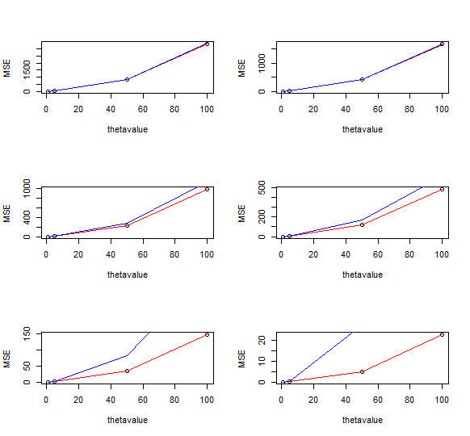

(d) **Observations**:

* From above results we can observe that, the MSE’s of both the estimators decrease as n increases, which means that as estimators become more accurate as n increases.
* They converge to the true parameter value in the given limit where MSE can be 0.
* It can also be seen that for n=1, MSEs of both estimators are almost same and when value of n is increased, like n>=5, MSE for MLE (theta 1) lies below that of MOME (theta 2).
* So, we can say that n=1, the two estimators hold good importance, but n>=5, the MLE is better when compared.

Thus, from graphs we can say that both MSEs are almost same for n=1,2 and for n>2, the ML Estimator is better than MOME.

Q2)

1. Derive expression for MLE of theta :

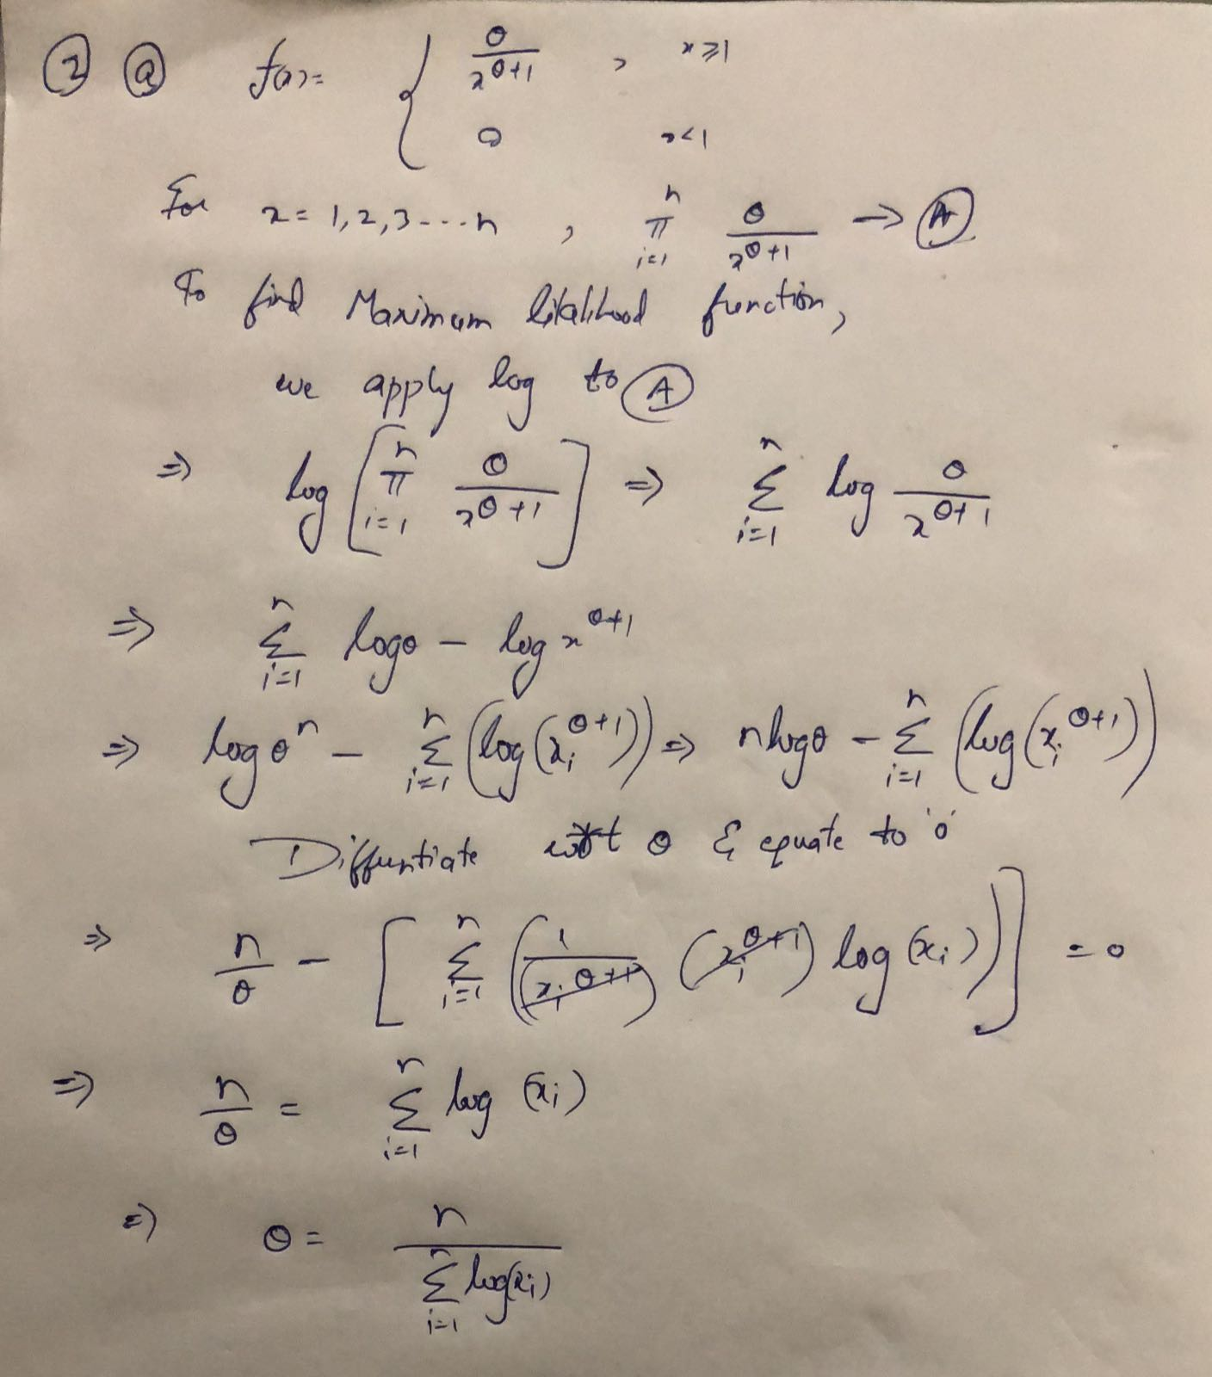

(b)

To compute MLE estimate based on given x values:

x=c(4.79,10.89,6.54,22.15)

logl<- 4*(1/sum(log(x)))

logl

**Result**: 0.4479208

(c) Using data in (b) to obtain the estimate by numerically maximizing the log-likelihood function using optim function in R:

neg_loglikelihood<- function(theta,x)

{

logl<- 4*(1/sum(log(x)))

return(-logl)

}

#Maximizing the Negative log likelihood function using optim function

max_lklhood.est <- optim(par=1,fn=neg_loglikelihood,method="BFGS",hessian = TRUE, x=c(4.79,10.89,6.54,22.15))

#finding the MLE

-max_lklhood.est$value

#**Result**: 0.4479208

* **Yes, my results match and are same.**

(d) Using output of numerical maximization in (c),

#standarderror of MLE

se=sqrt(diag((max_lklhood.est$hessian)))

se

#**Result** : 0.2239593

# to compute Confidence Interval assuming the dist is t-dist'ed

upperCI=max_lklhood.est$par + qt(0.975,3)*se

upperCI

lowerCI=max_lklhood.est$par -qt(0.975,3)*se

lowerCI.

**Reason:**

* **As we have considered t-distribution taking an assumption to be a normal distribution, so in this case the approximations will not be accurate.**
* **Here, if you increase sample size, the width of confidence intervals will increase is False.**
* **Increasing the sample size decreases the width of confidence intervals, because it decreases the standard error.**
* N**ote that the null value of the confidence interval for the relative risk is one. If a 95% CI for the relative risk includes the null value of 1, then there is insufficient evidence to conclude that the groups are statistically significantly different.**

**Since the sample size is small, and width is more (approx. 1.4254766) this doesn’t give a good approximation.**